NeuroWorks
AI Digital Workforce and Intelligent Organisation Platform

Project Title: NeuroWorks AI Digital Workforce and Intelligent Organisation Platform


Track Name: Track 3 Development
Team Name: NeuroWorks Lead Innovator: Aiia Rubiem Date: 12 July 2026
Project ID: NeuroWorks

FORMAT COMPLIANCE
Body: 5 required sections, Arial 11pt, 1.15 line spacing, 1-inch margins, ≤10 pages excluding this cover and the appendices. Submit as PDF only. File named Neuroworks_AI4I_Proposal_Development.pdf.

Section 1 Problem Definition & Strategic Alignment

The Problem
The organisational capacity crisis in Zimbabwe is not a technology problem or a skills problem in isolation. It is a structural design problem: the volume of knowledge work reconciliation, reporting, compliance, coordination structurally exceeds what an affordable number of hires can cover. A single NGO programme officer routinely performs the work of several specialists simultaneously; quality suffers, deadlines slip, compliance fails. Hiring is slow and expensive relative to the pace institutional mandates require. Job descriptions, qualifications, and org charts are industrial-era artefacts poorly suited to closing this gap.

Target Users and Beneficiaries
NeuroWorks is an operational B2B/B2G platform, not a consumer product. Twelve built-in sector context packs name real Zimbabwe-market institutional targets:

Sector | Named target users / institutions
Finance / fintech | Reconciliation desks, agent-network managers — RBZ framework, EcoCash, OneMoney
Agriculture | Field-reporting teams, input-financing coordinators — Pfumvudza/Intwasa, GMB
Health | Community health worker coordinators — MOHCC, DHIS2-integrated facilities
Education / Public services | Admin and reporting staff — ZIMSEC, PRAZ, ZIMRA, devolution departments
Tourism / Informal economy | Booking desks — ZTA, UNIVISA/KAZA; Mbare Musika market operators
Development / NGO | Grant reporting, donor coordination — WFP, WHO, UNICEF, UNDP cadences

Product Function and Expected Value
NeuroWorks turns a job description into a digital worker: an LLM-powered agent that receives a goal, forms a plan, calls tools through a governed allowlist, and pauses for human approval before anything consequential executes. It is briefed like a person and supervised like a new hire, not configured like software. Expected value is measured directly, not asserted: task completion rate, time saved against the prior manual process, cost per task, and non-technical operator adoption (§3.4, §5).

Strategic Alignment

Zimbabwe National AI Strategy
    - Talent and Capacity Development: NeuroWorks turns job descriptions into AI workers that perform roles at scale, and IntelliNexus turns agent output into governed, hash-verified institutional data a continuous capacity-building loop for the humans who supervise and learn alongside digital workers.
    - Computational and Data Sovereignty: the default architecture runs inference locally on operator-owned hardware (62.7% of measured calls served on a consumer GPU, §2.5); no data leaves the machine unless an operator explicitly opts into cloud escalation.
    - AI Adoption and Service Transformation: deployed AI workforce under an institution's own uploaded policies, not a pilot chatbot — pre-execution governance, mandatory human-in-the-loop approval, full audit trail, named institutional sector packs (PRAZ, MOHCC, ZTA).

    - Governance and Ethics: pre-execution policy enforcement, mandatory HITL, full audit trail, and AES-256-GCM credential encryption are the mechanics of governance, not a claim bolted onto a capability demo (§4).

NDS2 (2026–2030) verified against the primary document
NDS2 organises its programme around ten national priority areas (down from fourteen under the prior strategy), one per chapter (Ch. 3–12), each led by a Thematic Working Group. NDS2 places AI adoption directly under Priority 5 Science, Technology, Digital, Innovation and Human Capital Development committing that AI adoption "will be guided by the National AI Strategy" and naming "strengthening AI governance frameworks across all sectors of the economy" as an explicit intervention (NDS2 ¶1152–1153). NDS2 separately commits to expanding the Zimbabwe Centre for High-Performance Computing for, among other workloads, artificial intelligence (NDS2 ¶1101–1104) — the same CCE pathway addressed in §3.3.
NeuroWorks maps to five of the ten priority areas:

NDS2 priority area (chapter) | Fit | Evidence
Ch.7, Priority 5 Science, Technology, Digital, Innovation & Human Capital Development | Direct | Operationalises NDS2's named AI-governance commitment (¶1153) via pre-execution policy enforcement and full audit trail; ZCHPC/CCE pathway matches NDS2's own HPC-for-AI expansion plan (¶1101–1104)
Ch.12, Priority 10 Governance, Institution Building, Peace & Security | Direct | Governance engine, mandatory HITL, full audit trail on every agent action
Ch.9, Priority 7 Regional Development & Inclusivity through Devolution & Decentralisation | Direct | Named alignment to PRAZ and devolution-agenda departments (§1.2)
Ch.3, Priority 1 Macro-Economic Stability & Financial Sector Deepening | Partial | Reconciliation workflows for fintech desks; NDS2 names fintech/digitalisation expansion under Financial Sector Deepening (¶286–290)
Ch.10, Priority 8 Social Development, Gender & Social Protection | Partial | Community-health-worker coordination in the health sector pack (§1.2)
No claim is made against the remaining five priority areas (Inclusive Economic Growth & Structural Transformation; Infrastructural Development & Housing; Agriculture, Food, Climate & Environment; Job Creation, Youth Entrepreneurship, Creative Industry, Sport & Culture; Image Building, International Relations & Trade). Stated plainly rather than stretched to fit.

Section 2 Technical Design & Product Logic

System Architecture
Three layers (full diagram: Appendix A). Layer 1 tools and infrastructure (PostgreSQL, Qdrant, Ollama, Redis, payment/comms rails). Layer 2 HERMES, an MCP tool-governance layer of ~90 allowlisted primitives across 12 namespaces defining exactly what agents can and cannot do. Layer 3 LangGraph multi-agent digital workers that plan, call tools through HERMES, and stop at a mandatory HITL gate before consequential actions execute.

Component | Detail
Backend | Node.js / TypeScript, Express — 28 live routers, 85 lib files, 46 route handlers. No scaffolding stubs.
Frontend | Next.js 14 / React / TypeScript — 37 pages (console, Mission Control, governance manager, cost dashboard).
Orchestration | LangGraph multi-agent; structured audit logging on every action.
Inference | Ollama (local, default) + OpenRouter/Claude (cloud, opt-in, circuit-breaker fallback to Ollama).
Data | PostgreSQL (relational), Qdrant (RAG, org-isolated, HNSW), Redis (working memory/queues).
Secrets | AES-256-GCM encrypted store (secret-box.ts); never logged or passed by value into agent context.

AI Justification & Model Rationale
Per capability, stated against the ToR's sledgehammer test — would ordinary rules or SQL suffice?

Capability | Why AI, not rules/SQL | Model tier used
Reconciliation synthesis across 24 DB tables vs. a natural-language policy doc | Requires interpreting an unstructured policy document alongside structured data — not expressible as a fixed query | Local 7B default; escalates only on quality.check failure
Donor-report narrative drafting from an uploaded PDF | Free-text synthesis with institution-specific compliance framing — no fixed template covers this | Local 7B default; cloud opt-in for long/complex documents
Shona/Ndebele service-policy chat | Natural-language understanding across two under-resourced languages within dynamic policy bounds | Local, glossary-grounded — no external API
Policy-document → structured constraint extraction | Converts arbitrary prose policy into hard/soft rule sets — a genuinely open-ended language task | Local LLM, human-reviewed before activation
Routine data lookups (org.lookup, db.list_tables) | Deliberately NOT routed through an LLM — plain function calls | No model — direct primitive, by design
The last row is included deliberately: NeuroWorks does not route every action through an LLM. Primitives with a deterministic answer are implemented as plain function calls; the model is

invoked only where language understanding, multi-step planning, or context synthesis is genuinely required. This is the concrete evidence against forced or cosmetic AI use.

Dataset Statement & Provenance

Source | Type | Size / status | Licence | Limitations
Production PostgreSQL | Real, operator-owned | 5 org connected  live, 11 Jul 2026 | Operator data; NeuroWorks is processor, read-only by default | Single connected source to date
Awesome curated-software dataset | Real, third-party, ingested via IntelliNexus | 682 records | CC0 — verified against source repo metadata before ingestion | Software-domain only; not Zimbabwe-sector data
Nightly self-reflection series | Real, NeuroWorks' own operational telemetry | Growing, daily | Internal | Operational metadata, not user/beneficiary data
Zimbabwe sector knowledge packs (Stream D, in build) | To be collected — public-domain and institution-provided sources | 5 packs planned | Planned release: CC BY 4.0 | Not yet ingested; content sourcing not yet finalised
NO SYNTHETIC DATA GENERATION
NeuroWorks does not use GAN, diffusion, or other synthetic data generation methods anywhere in the current build. Test fixtures for the 118-test unit suite use hand-constructed sample records, not generative synthesis stated plainly to avoid any ambiguity under this criterion.

User Interaction Plan
Operators interact through the Next.js console (37 pages) or brief a worker in natural language, the way they would brief a new hire: select a sector/language pack, state a goal in plain language, upload a policy document (auto-converted to constraints), approve or decline the worker's first proposed action at the HITL gate, then review output in their own language. No prompt engineering or technical configuration is required for this path; a full non-technical-operator walkthrough is at §4.4.

Local-Inference Resource Envelope

NOT AN EMBEDDED/ EDGE DEPLOYMENT
NeuroWorks' local inference runs on operator-owned GPU workstation or server hardware (Ollama), not an embedded or mobile device. The ToR's edge bar (<256MB RAM, <100ms latency) targets embedded/mobile AI and does not govern this submission's inference tier. The figures below are the correct, measured comparison for a local/on-premise GPU deployment.
Metric | Measured / specified value
Reference hardware | Consumer RTX 3060, 12GB VRAM
Default local models | Llama 3.2 3B / Qwen 2.5 7B (quantised)
Share of calls served locally (measured, 10 | 62.7% (640 / 1,021 calls)

days)
Measured cloud-escalation cost | USD 8.31 / 1,021 calls (~USD 0.10/task on a fully-documented day)
Optional high-capability local tier | Llama 3.3 70B quantised, for 48GB+ VRAM hosts — no foreign data transmission

API Layer, Integrations & Governance Engine
All external integrations are exposed as named HERMES primitives; no agent can call outside this allowlist, and writes/communications require explicit HITL approval. Operators upload policy documents; a local LLM converts them into hard/soft constraint sets, displayed for review before activation and enforced pre-execution at the HITL gate 20 categories of consequential tool calls are currently gated this way.

Section 3 Deliverables & CCE Implementation Roadmap

Current Build Status (live, verifiable)
28 live API routers with real handlers (no scaffolding stubs) · ~90 primitives across 12 namespaces · 141 skill playbooks, no orphans · one production PostgreSQL connected live and read-only · IntelliNexus dataset published with a verifiable Merkle root hash · governance engine enforcing 20 categories pre-execution · Mailjet, Paynow Zimbabwe, and Stripe all live-tested · 118 unit tests passing · dependency manifest locked via package-lock.json at repository root · structured, incremental Git commit history (not single-commit uploads).

Delivery Streams

Stream | Weeks | Deliverable
B —  Onboarding UX | 1–3 | Sector/language selection, personalised dashboard, Shona/Ndebele i18n strings
C —  Governance UI | 3–4 | Policy upload, constraint review, hard/soft marking, HITL violation flagging
D —  Localisation | 5–6 | Shona/Ndebele agent prompts; five sector packs ingested via IntelliNexus
E — Platform integrity | 7–8 | Cost dashboard, full audit-log replay, SkillForge code-review step
F — Polish & docs | 9–12 | Mobile-responsive console, governance framework doc, pilot plan

Milestones, Compute, and ZCHPC CCE Position

Milestone | Deliverable | Compute / dependencies | When
M0 —  Challenge demo | Live: db.* query on production data, Mailjet send, Paynow flow, local inference, governance gate firing on a planted violation. 118 tests green. | Team hardware (RTX 3060). No ZCHPC CCE  required. | 31  Jul 2026
M1 — Contract signing | Stream B in staging; dependency manifest locked. | Same hardware; Qdrant/PostgreSQL/Redi s local or free-tier hosted. | Week 1
M2 — First tranche | Streams C & D live; native-speaker-reviewed prompts; 5 sector packs ingested. | Managed Qdrant; OpenRouter key for quality testing. | Week 6
M3 — Pilot launch | 10–20 pilot orgs onboarded; first non-technical operator case study. | Hosted PostgreSQL + Redis + Qdrant, est. USD 40–60/month. | Week s 7–  12
NeuroWorks does not require the ZCHPC CCE for primary operation the default path runs Ollama on operator-owned hardware. For pilot organisations without GPU hardware, ZCHPC access would provide shared local inference in a controlled, data-sovereign environment. If accessed: 1× GPU node (16GB+ VRAM), 32GB RAM, 100GB storage, outbound access for

GitHub API and optional OpenRouter fallback, all dependencies declared in package-lock.json at repository root.

Pilot Evidence Plan
No signed pilot exists at submission. Rather than assert impact, this is the dated path to first evidence: by 20 July, shortlist five candidate organisations from the named sector-pack institutions (§1.2); by 24 July, secure at least one verbal agreement to run a scoped, time-boxed reconciliation task on the organisation's own data during bootcamp week; during 27 Jul–1 Aug, run it live and capture before/after time and error-rate metrics directly, not self-reported; by 1 Aug, convert to a signed LOI for the Weeks 7–12 pilot slot (§3.3, M3), or disclose specifically why it did not convert.

Section 4 Compliance & Risk Mitigation

Written candidly: where a risk is mitigated, the mitigation is named and locatable in the code; where it is not, that is stated plainly.

Ethical Safeguards
Hallucination is mitigated at four layers: anti-fabrication rules requiring inline evidence citation; quality.check scoring every non-trivial answer with a rescue pass on low scores; peer.review sending low-confidence drafts to a second model; and a DATA GAP injection forcing disclosure when a required source was unavailable. Bias has not been independently evaluated against Zimbabwe-context prompts; a structured bias probe (gender, urban/rural, English/Shona/Ndebele framing) is scheduled before Stream D sector packs reach a pilot organisation. Shona/Ndebele output is functionally verified but not yet reviewed by a native-speaker linguistic authority scheduled within Stream D, logged as a governance-engine gate a pilot cannot pass without.

Data Protection Act (Chapter 12:07) Compliance
DPA obligations sit with the connecting operator as data controller; NeuroWorks acts as processor on read-only instructions. Connections are read-only by default; credentials are encrypted at rest (AES-256-GCM, secret-box.ts); no data is exported, cached beyond mission scope, or published via IntelliNexus without explicit operator instruction; every query against a connected source is captured in a full audit trail. In the default configuration (local Ollama, local vault, local Qdrant) personal data never leaves the operator's machine.

Data-Use Consent
CURRENT STATUS
A dedicated data-use consent checkbox in the onboarding UI is not yet implemented stated plainly rather than implied. Consent is currently enforced structurally: connections default to read-only, and no external publication of operator data occurs without an explicit, logged instruction per action. An explicit consent checkbox, presented at first data-source connection and logged with a timestamp against the org record, is scheduled for Stream B (§3.2, Weeks 1–3), ahead of the Weeks 7–12 pilot cohort.

Testing, Validation, and Non-Technical Operator Check
118 unit tests pass. The governance gate was tested against planted policy violations: it fires correctly and surfaces the specific violated rule before any action executes. A secret-pattern scanner detected a planted fake token in under 1ms. The cost tracker was audited and a 19% undercount bug found and corrected (11 Jul 2026).

Step (non-technical operator persona: rural clinic administrator) | What they see
1. Select sector + language from a dropdown | No visibility into routers, primitives, or stack
2. Brief the worker in plain language | No prompt engineering required
3. Upload existing MOHCC reporting guideline as PDF | Governance engine converts it to constraints automatically
4. Approve first proposed action (HITL gate) | Plain-language summary; one-tap

Step (non-technical operator persona: rural clinic administrator) | What they see
 | approve/decline
5. Read the weekly summary in their own language | No log/hash inspection needed unless something looks wrong

Cybersecurity Protections
A real credential incident is disclosed deliberately: a GitHub PAT was inadvertently displayed in terminal output during development, caught immediately, rotated within the same session, old credential revoked. Origin-guard middleware defends against DNS rebinding and cross-origin attacks. code.exec is unsandboxed and disabled by default (explicit env flag required to enable); SkillForge-generated code runs in an E2B isolated sandbox before any operator approval or persistence. Asset and licence register: all third-party libraries, models, and APIs are declared with licence positions in the repository's Asset and Licence Register (Appendix B).

Section 5 Sustainability & Future Adoption

Cost Projections (measured, not estimated)

Period | Total calls | Free/local | Paid cloud | Cloud cost
10 days, 3–11 Jul 2026 | 1,021 | 640 (62.7%) | 381 (37.3%) | USD 8.31 total
Single day, 10 Jul 2026 | ~35 | ~22 | ~13 | USD 3.03 (~USD  0.10/task)

Operating Cost Model and Break-Even (illustrative, to refine with real payroll)
Estimated monthly operating cost ≈ USD 21,000 (5 FTE blended team cost ~USD 17,500; hosting ~USD 50; cloud-inference buffer ~USD 150; ~15% overhead ~USD 3,300). Priced against this: Growth tier at USD 105/month breaks even at 200 organisations; Institutional tier at USD 300/month (~USD 3,600/yr annual licence, incl. support and deployment assistance) breaks even at 70 organisations both converging on the same ~USD 21,000/month target independently, so the model does not depend on hitting both simultaneously. Every installation still runs Ollama by default at zero mandatory cloud spend; a managed relay for hard-to-self-host pieces is planned, not yet built.

Licensing Registry
NeuroWorks' code is proprietary to Aiia & Rubiem, all rights reserved (full licence at repository root). POTRAZ is granted a non-exclusive, royalty-free right to evaluate, demonstrate, and pilot the submission for public-interest purposes; commercial use beyond the Challenge requires a separate agreement. Third-party libraries, models, and APIs are declared in the Asset and Licence Register (Appendix B). Zimbabwe sector knowledge packs will be released under CC BY 4.0.

Scaling Pathway
The formal pilot (Weeks 7–12 post-award) targets 10–20 organisations in Mutare and Harare across SMEs, NGOs, government-adjacent institutions, and one health facility, measured on task completion rate, time saved, cost per task, and at least one non-technical operator case study. SADC regional expansion follows the same architecture with country-specific language/regulatory packs — configuration, not a rebuild. For sovereign government deployment, on-premise with ZCHPC GPU infrastructure avoids cloud dependency; a source-code escrow arrangement is a reasonable structural safeguard against vendor-discontinuation risk and is disclosed here as a commitment to negotiate, not a completed mitigation.

Appendix A System Architecture Diagram

Not counted towards the 10-page limit. Referenced from Section 2.1.
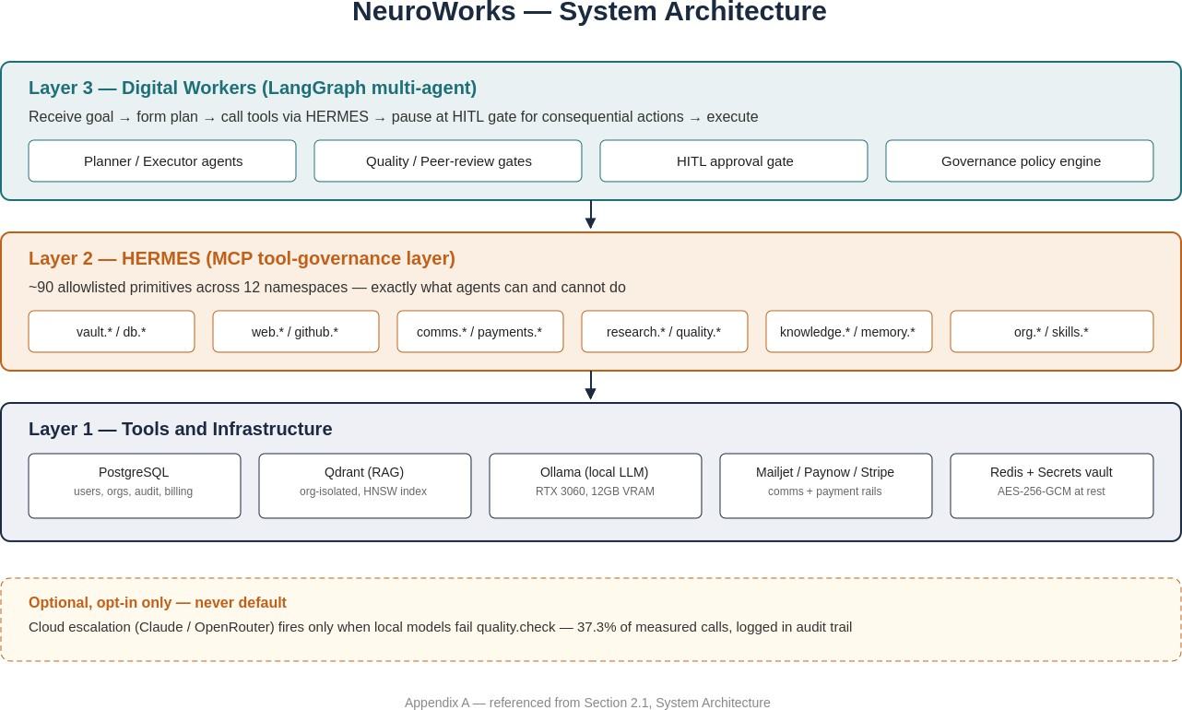

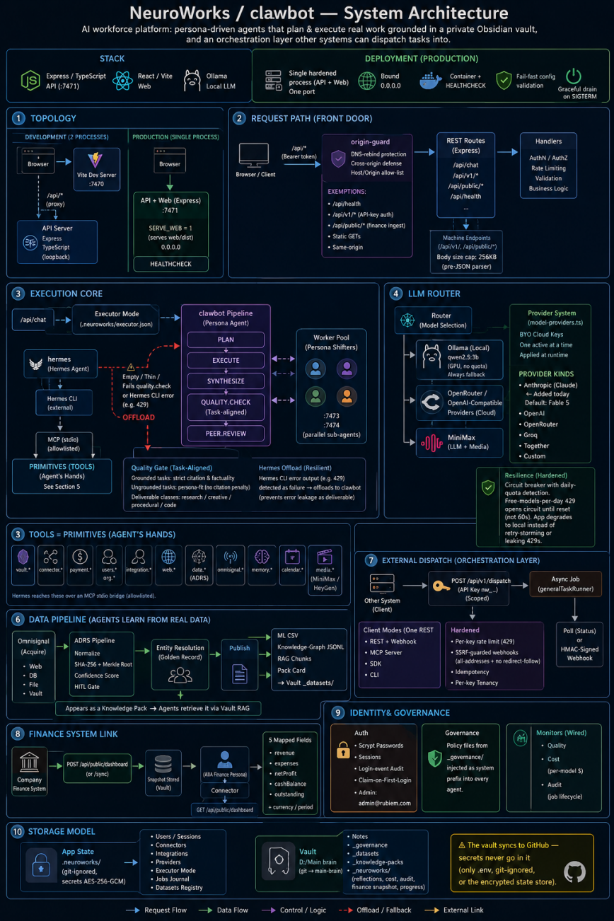

Appendix B Asset and Licence Register (extract)

Not counted towards the 10-page limit. Referenced from Section 4.5 / 5.3. Full register maintained at docs-vault-ready/06-grand-challenge-2026/ in the repository.

Asset | Type | Licence / terms
Ollama runtime + Llama 3.2 / Qwen  2.5 / Llama 3.3 weights | Local inference | Open-weight, per-model licence (Meta Llama Community Licence; Apache 2.0 for Qwen)
Claude Sonnet 5 / Haiku 4.5 (Anthropic API) | Cloud inference, opt-in | Commercial API terms, billed at cost  + 10% platform fee
OpenRouter | Cloud routing fallback | Commercial API terms
CLIP, Whisper | Open-weight multimodal models | MIT
PostgreSQL, Redis, Qdrant | Data infrastructure | Open-source (PostgreSQL Licence, BSD, Apache 2.0)
Stripe, Mailjet, Paynow Zimbabwe SDKs | Payment / comms rails | Commercial API terms
Awesome curated-software dataset | IntelliNexus-ingested dataset | CC0
NeuroWorks application code | Proprietary | All rights reserved, Aiia Rubiem / RUBIEM Developers
Zimbabwe sector knowledge packs (planned) | Dataset | CC BY 4.0 on release

